Technical Datasheet WIN-SN-7n1ENV-W Sensor

The Sensor Unit collects the environmental data of 8 parameters from the indoor surrounding and displays the data as well as sends the data to the Cloud over MQTT protocol over WI-FI.The unit is robustly designed for continuous 24/7 operation and is exceptionally easy to use.

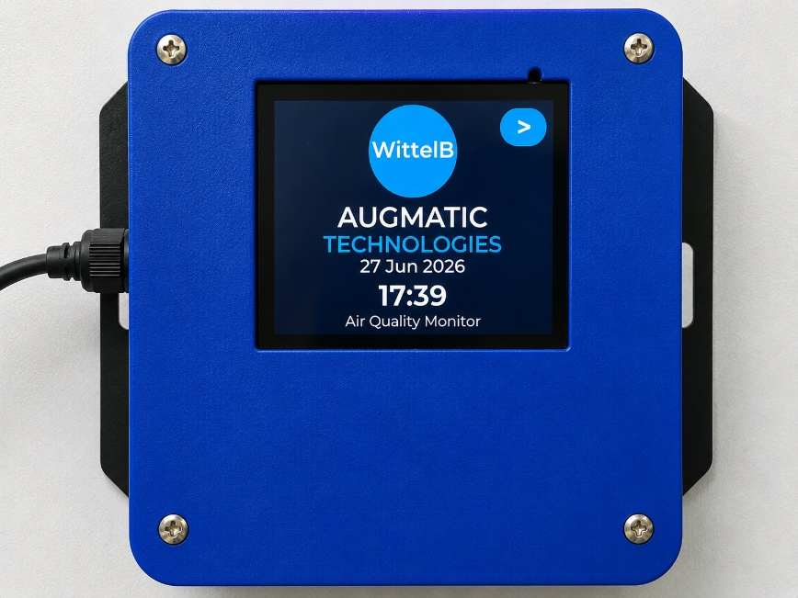
Display Module: -

The module is housed in a rugged industrial enclosure with wall mounting slots featuring an integrated display for easy installation deployment. Configuration settings such as Wi-Fi connectivity, MQTT parameters and cloud communication can be managed through the integrated display interface or the built-in web portal.
The modules are designed for reliable long-term operation with built-in protection, ensuring enhanced safety and system reliability. The Display Unit collects, displays, and securely publishes sensor data to the cloud using the MQTT protocol, enabling continuous remote monitoring and data access.

Specifications
General –
Dimensions 98 mm L x 98 mm B x 34 mm H
Power Input Power – 5 VDC Type C
Operating Temperature -20°C to +80°C (-4°F to +176°F)
Storage temperature -20°C to +80°C (-4°F to +176°F)

Storage Humidity 5 ~ 95 % RH, non – Condensing
Certifications

Operator Interface & Navigation Guide

1. Initial Network Provisioning (Wi-Fi Setup):
Upon first boot—or when a network change is required—the device enters Access Point (AP) mode. The screen displays a "Wi-Fi Setup Required" prompt, broadcasting its own local network. Users simply connect to this network via a mobile device or laptop using the Password 12345678 and navigate to the provided IP address (ex: 192.168.4.1) to securely pass local Wi-Fi credentials to the unit.
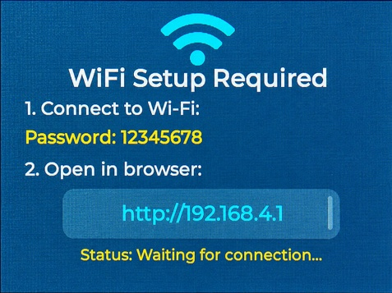

2. Home Screen & Main Navigation
Once provisioned, the device boots to the Home Screen, displaying the company logo, current date/time, and system title. Tapping the [ > ] icon in the top right corner opens the Main Menu, which splits the interface into two primary pathways:
- AQI Dashboard: For live data of the sensors.
- MQTT Cloud : Indicates the current cloud connection status (Connected/Disconnected).
- WIFI Settings : Configure the device whenever the Wi-Fi network changes.
- MQTT Setup: Configuration settings for the MQTT Connections.

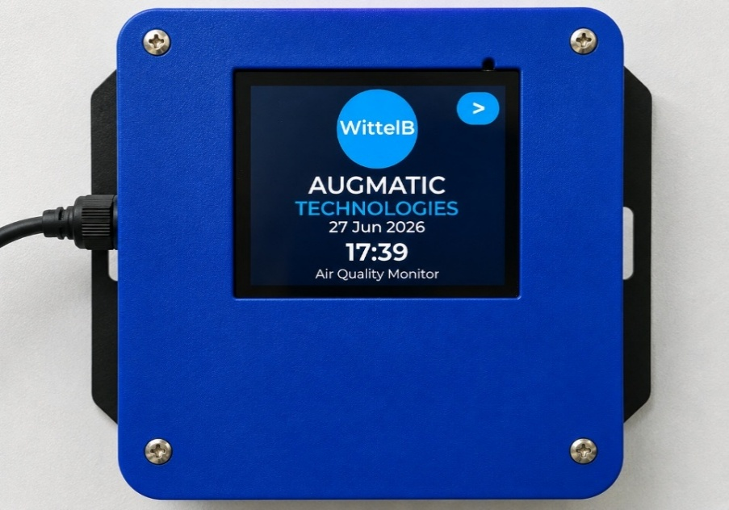
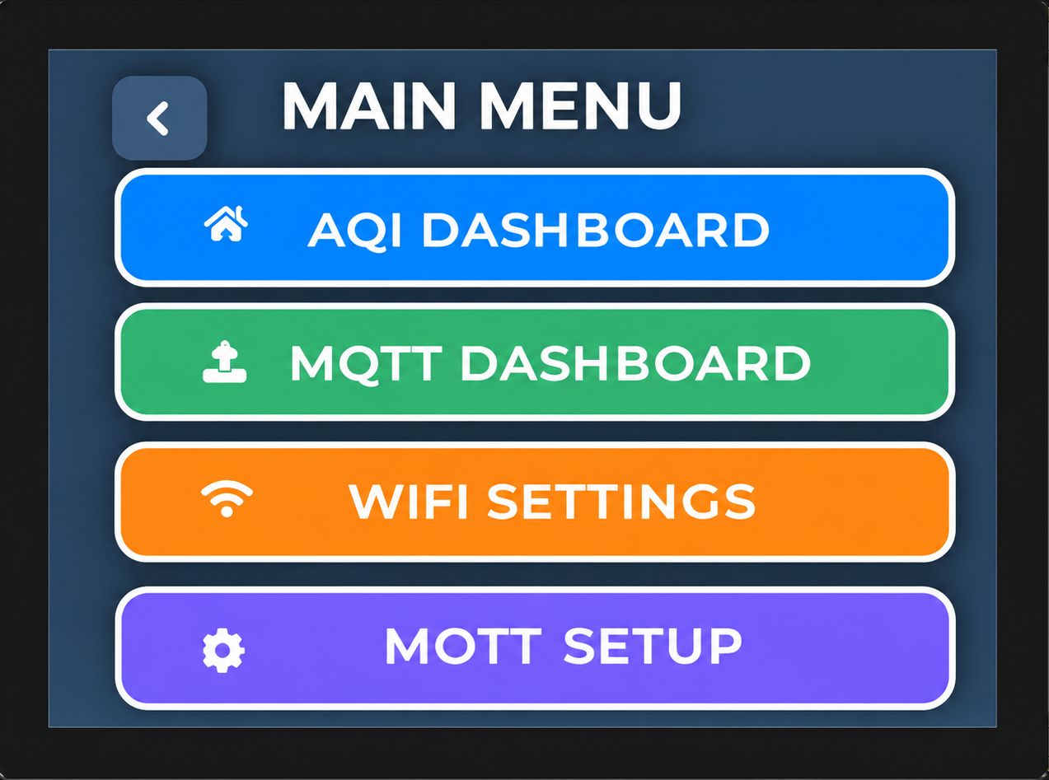

3. Live Telemetry Dashboard
The Dashboard provides a clear, real-time view of all monitored air quality parameters on a single screen, enabling users to quickly assess the current environmental conditions.
- Real-Time Monitoring: Displays the latest values of all connected sensors, including Temperature, Humidity, PM1.0, PM2.5, PM10, CO2, AQI, and TVOC.
- Color-Coded Display: Each parameter is presented in a dedicated color-coded tile for improved readability and quick identification.
- Instant Data Updates: Sensor readings are refreshed continuously, providing up-to-date information for effective environmental monitoring.
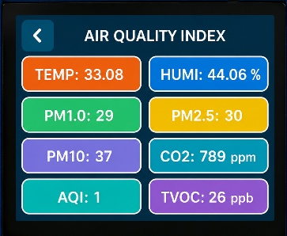
- User-Friendly Interface: The intuitive display allows users to easily view and monitor all air quality parameters from a single dashboard screen.

4. MQTT Status & Configuration
The MQTT interface provides a clear, real-time overview of the device's cloud connectivity and data transmission settings, enabling users to easily verify their network parameters and current connection state
- Live Connection Status: Displays the real-time MQTT connection state (e.g., Connected or Disconnected) in a dedicated color-coded tile to quickly verify cloud communication.
- Broker Details: Shows the designated MQTT broker address or IP that the device is currently configured to communicate with.
- Topic Configuration: Displays the active MQTT topic path where the device is publishing its telemetry data.
- Publish Interval: Indicates the frequency (e.g., 5 Seconds) at which the device transmits updated sensor readings to the cloud broker.
- Web-Based Setup: The setup screen displays the active Wi-Fi network and provides a direct local IP address (e.g., http://192.168.1.60). Users simply enter this IP into a mobile or PC browser to securely access the web portal and configure the MQTT parameters.
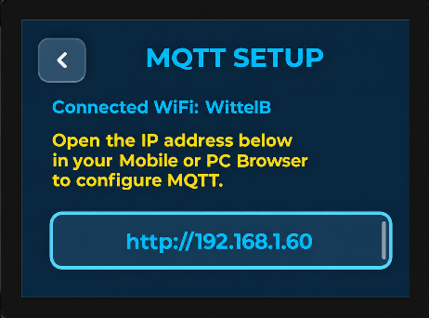
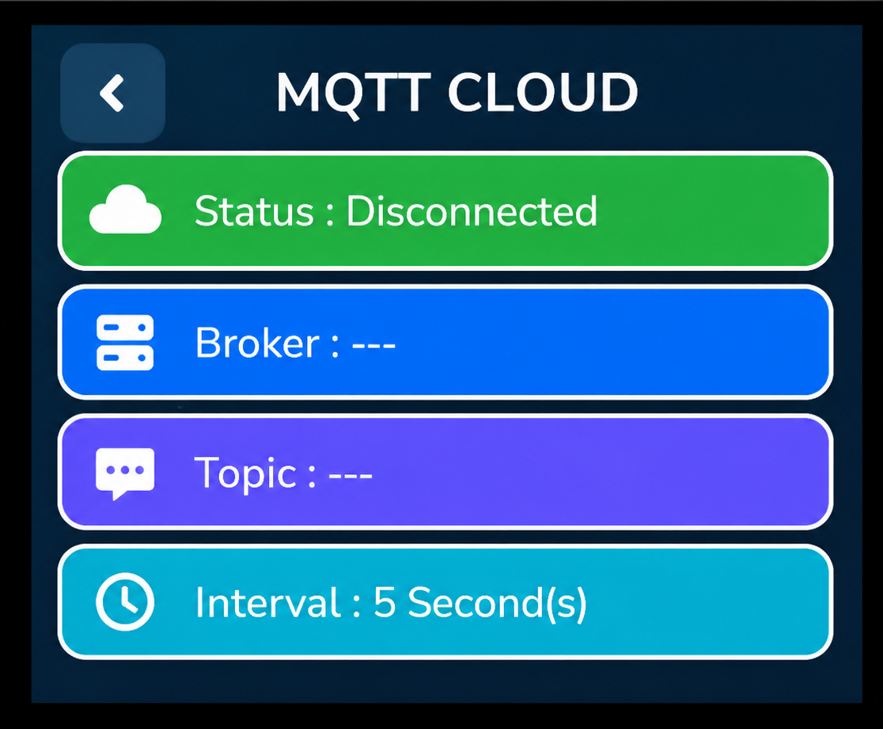

Web Portal Configuration Guide
1. Accessing the Wi-Fi Manager
- Navigating to the device's IP address opens the main WIFI Manager portal.
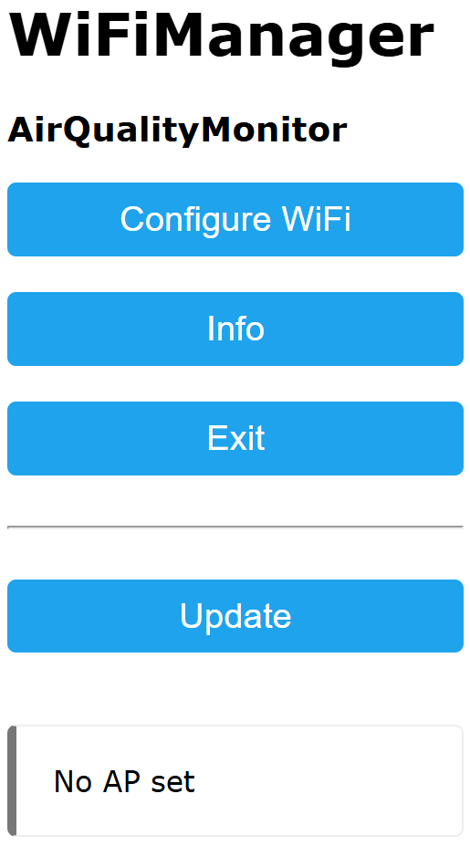
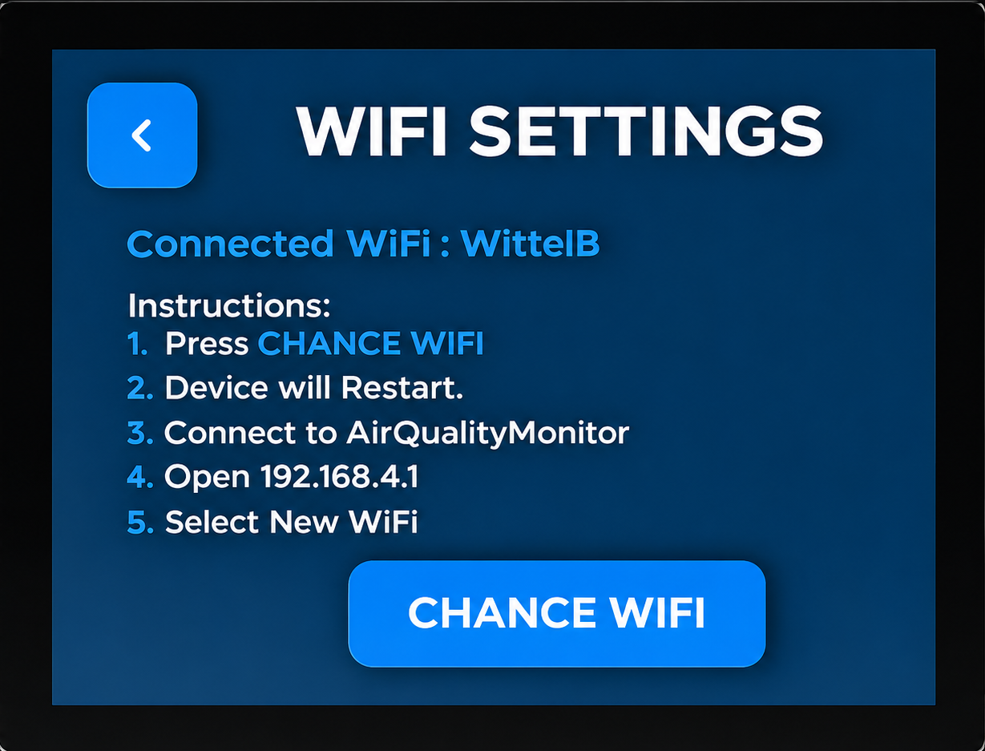
- Click the [Configure Wi-Fi] button to proceed to the network selection page.

2. Selecting the Network
- The setup page displays a list of available Wi-Fi networks in range.
- Tap the desired network from the list to automatically populate the SSID input field or type the SSID manually.
- Enter the network security key into the Password input field.
- Click the Save button to commit the credentials.
- The device will then process the information and connect to the assigned Wi-Fi network.
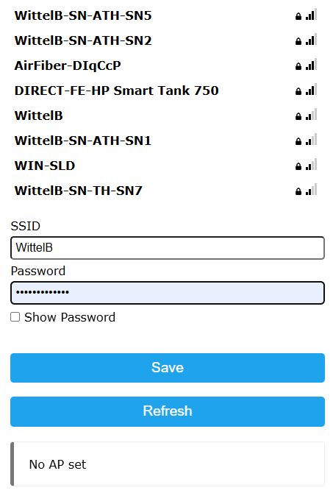

Web Portal Configuration Guide (Air Quality Monitor)

The embedded web portal is dedicated to configuring Wi-Fi and MQTT cloud settings, enabling seamless cloud connectivity and remote sensor data monitoring.

1. Accessing the Settings
- Enter the IP address shown in the MQTT Setup page.
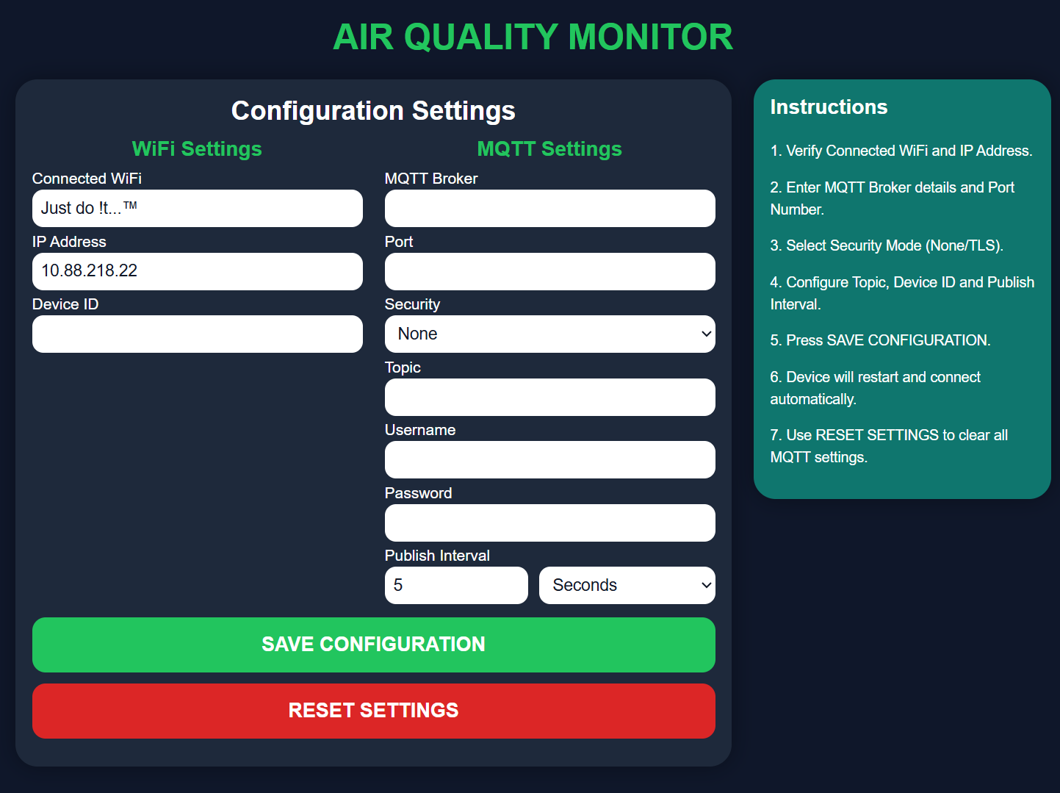
- Then, you will be redirected to the cloud Settings page, where you can enter the cloud configuration details to publish the data to the MQTT Cloud.
- (Note: The IP address will be different for each Wi-Fi networks)

Instructions:
- Connect the device to a Wi-Fi network and verify that a valid IP address is assigned.
- Enter the MQTT Broker address and Port number.
- Select the required Security mode (None/TLS).
- Enter the MQTT Topic, Device ID, Username, and Password (if authentication is enabled).
- Set the desired Publish Interval and select the time unit (Seconds or Minutes). The device will automatically publish sensor data to the MQTT cloud at the selected time interval.
- Click SAVE CONFIGURATION to store the settings.
- The device will automatically restart and reconnect using the new configuration.
- The default MQTT publish interval is 5 seconds.
- The display refreshes sensor readings every 2 seconds to provide near real-time monitoring.
- CO₂, AQI, and TVOC sensors require approximately 3 minutes of warm-up time after power-up before providing stable and accurate readings.
- Verify the cloud connection status to ensure sensor data is being published successfully.
- Click RESET SETTINGS to clear all saved MQTT configuration and restore the default cloud settings.

Contact us: -
Augmatic Technologies Pvt. Ltd.,
Plot no 6, Shah Industrial Estate II,
Kotambi,
Vadodara – 391510.
Email – Sales@wittelb.com
Support: support@wittelb.raiseaticket.com / +91 94038 92805

